for more information contact: Elder Services @ 413-499-0524

Hoarding Disorder:

Fact, Fiction & Family
A Community Conversation with Becca Belofsky and
Lee Shuer
Tuesday, June 27, 2023
8:30 am Registration
9:00am-12:00 pm Presentation
Country Club of Pittsfield
639 South Street, Pittsfield, MA 01201

Open & Free to the Public. Space is limited.
Register Here by June 16, 2023 or at www.ESBCI.org under events
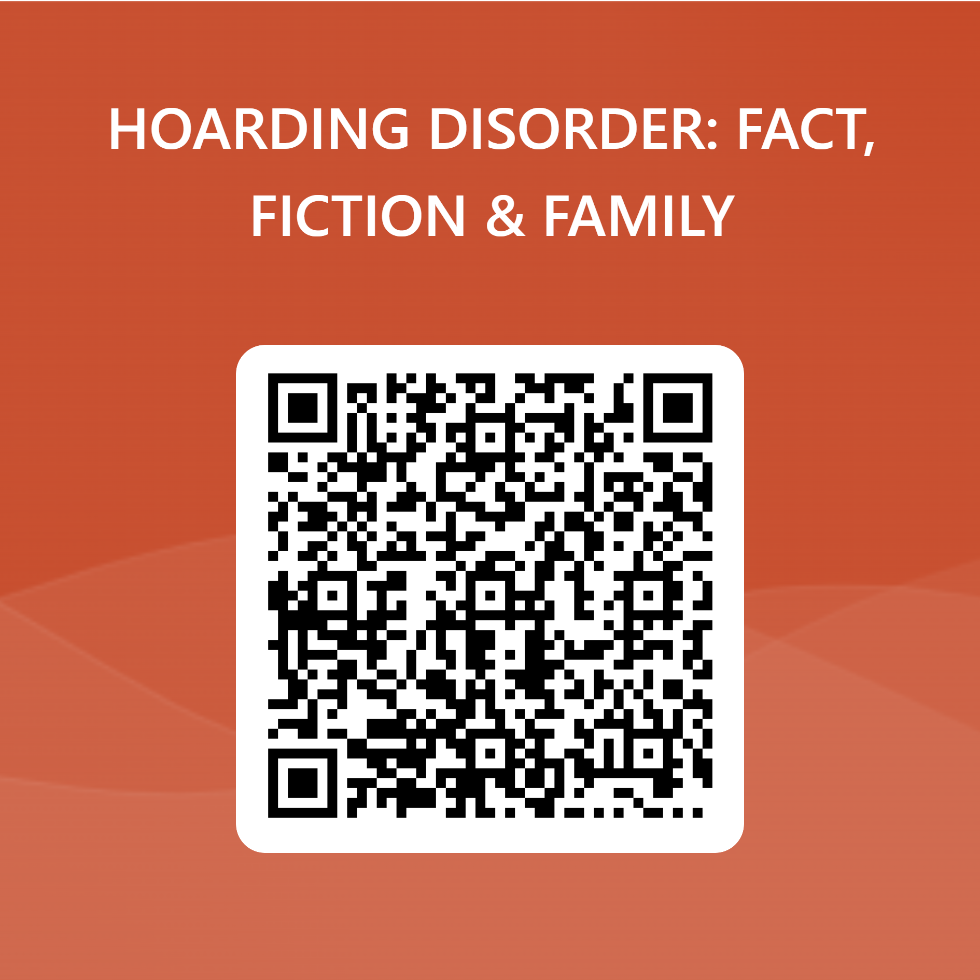

Hoarding disorder (HD) is a diagnosable, treatable mental health challenge, and recovery is possible! An estimated 5% of the population struggles with HD, but that’s not the whole story. Their family members are also impacted by their overwhelming attachment to things. The way forward begins with building trust and developing a plan that addresses the most significant concerns in the least invasive, most time-sensitive way. Join us for a conversation that connects the dots as we create a 3 foot wide path to a safer, more comfortable future.
"This event has been produced in part from a grant awarded to the Massachusetts Association of Councils on Aging by the Massachusetts Executive Office of Elder Affairs”

